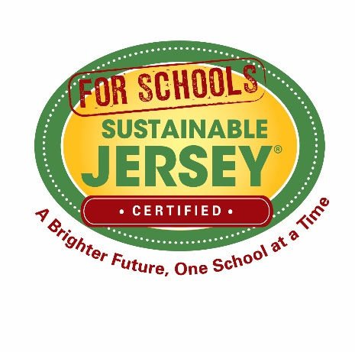
Resolution to Participate in Sustainable Jersey for Schools
Achieving environmental, social, and economic sustainability will require a commitment from all sectors of society. New Jersey’s public school districts and charter schools are in a unique position to make substantial contributions toward the goal of a sustainable world for future generations. Schools engage a community of students, families, educators and other staff. A school that embraces and promotes sustainability in its various operations, including planning, facilities, teaching, and outreach, will help to instill in the school community a shared understanding of the importance of sustainability and how each person can help achieve it.
Sustainable Jersey for Schools recognizes and promotes best practices that result in a healthier school climate, improve the educational program, and conserve our schools’ limited physical and financial resources.
The Sustainable Jersey for Schools program is a voluntary program. Participation does not obligate the school district to any specific time commitment or budgetary obligations. Districts and schools may choose to cease program participation at any time.
Step 1: Pass a Resolution. Your school board must pass a resolution that states its intention to pursue Sustainable Jersey for Schools certification and designate a person to be the formal liaison to the Sustainable Jersey for Schools program. Use the sample resolution below.
Step 2: Register. After the resolution is adopted, complete the online registration form on the Sustainable Jersey for Schools website at www.sustainablejerseyschools.com, and upload the adopted school board resolution. Your registration will be reviewed and in a few days your liaison will receive an email message with information about accessing your account on the Sustainable Jersey for Schools website.
Sample Resolution:
Participation in the Sustainable Jersey for Schools Certification Program

Whereas—The ________________ Board of Education (or Board of Trustees) seeks to participate in Sustainable Jersey for Schools to focus attention and efforts on matters of sustainability and pursue initiatives that will lead to Sustainable Jersey for Schools Certification.

Whereas—The _____________ Board of Education and District Superintendent seek to support and work with school staff and administrators, students, and parents to ensure a safe and healthy environment for students by encouraging our school community to implement sustainable, energy-smart, eco-friendly, and cost-effective solutions.
Whereas—Extensive opportunities exist to teach students about ecological, economic and social sustainability, environmental health, and nutrition; to integrate sustainability education into classroom learning; and to support students in becoming leaders in making their schools healthier and more sustainable places.

Whereas—Many options and choices exist for schools to use resources more efficiently; to reduce, reuse, and recycle; to follow Green Building Standards for construction and major renovations; to form school partnerships; to eliminate toxic chemicals; to purchase (or produce) clean energy; and to purchase recycled paper, energy-efficient equipment and other green products to protect our global environment.

Whereas—Sustainability means using resources wisely, saving money, and reducing our impact on the environment, all of which will ensure the future health, safety, and prosperity of our children.

Whereas—The ___________ Board of Education commits to the formation of at least one Sustainability Leadership Team (also referred to as “Green Team”), based on the guidance of Sustainable Jersey for Schools. (See the “Create A Green Team” action. Your district “Green Team” can be designated from a pre-existing group within the district if desired.).

Whereas—Green Team members help schools adopt policies and practices addressing areas such as sustainability education and professional training, green purchasing, waste reduction, indoor air quality, energy-saving initiatives, and community partnerships.

Whereas—The __________ Board of Education will encourage Green Teams at all district schools by providing networking and educational opportunities.
Therefore, it is resolved that the ________________ Board of Education agrees to participate in Sustainable Jersey for Schools, and it is the board’s intention to pursue certification for schools in the district.

We hereby appoint _____________ ____________________________________________________ to be the district’s liaison to Sustainable Jersey for Schools.
We do hereby recognize our School(s) as the agent(s) to carry out our commitment to building a sustainable school district through the implementation of Sustainable Jersey for Schools actions.
We agree to complete district actions and to support the district’s schools in completing their actions.

Signature of Board Secretary Date

________________________________________ ________________

OR provide all three signatures below

Signature of President of the Board of Education Date

_________________________________________ _______________

Signature of District Superintendent Date

_________________________________________ _______________

Signature of Business Administrator Date

_________________________________________ _______________

