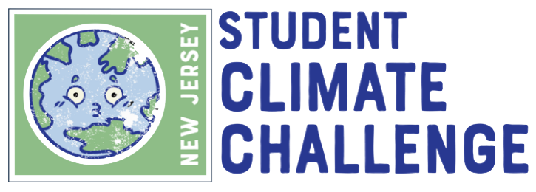

STUDENT GUIDE

Table of Contents
1. New Jersey Student Climate Challenge Overview 2
2. Tips for Getting Started 2
3. Climate Challenge Eligible Student Projects and Student Teams 3
4. Resources to Support Action Project Planning and Implementation 3
5. Resources to Support Digital Story Video Production 7
6. Submission Requirements and Form 10
7. Submission Review Process 11
8. Challenge Awards 12
9. Questions? 12

New Jersey Student Climate Challenge Overview

Students can be powerful agents of change when addressing issues that are important to them. Your passion for action is often the catalyst that influences others to do the same. The earth’s warming over the next decade is unavoidable. Rising sea levels, increasing temperatures, shifts in rainfall and storm patterns, and chronic flooding are a few of the changes impacting our economy, health, environment, and society. Once an abstract concept, climate change is a reality impacting your school and community today. These impacts will continue to increase in severity unless you are equipped with the knowledge and skills needed to become a generation of climate literate leaders, including policymakers, scientists, teachers, entrepreneurs and more, who will develop solutions and lead the green economy.

The Challenge provides a hands-on learning opportunity to build an understanding of climate change and address its impacts through collaborative action. To participate, a student team completes a school or community project to address a cause or impact of climate change and creates a short digital story. The digital story not only shares your experience but can be a tool to motivate others to act too.

By the end of their project, you should be able to communicate to others why climate change is an important issue and, more critically, what you are doing to address it. Learning about locally relevant climate issues has been shown to have a long-lasting positive impact on hopefulness towards the future and the future of our planet.

Suggestions for project planning and digital story-making tips are provided later in this guide. Other resources such as action project brainstorming, video techniques, and completing the Challenge application are also available in this document.

Tips for Getting Started

- Review the Challenge Official Rules.
- Become familiar with the scoring rubric found later in this guide. Through your participation in the Climate Challenge, your team will engage project-based learning experience to brainstorm, research, design, and implement a climate action project of your choosing.
- Document your progress throughout the project to create a digital story the project and how it will help in combat climate change.
- Review the submission form PDF to acquaint yourself with entry deadline and requirement.
- Conduct research on different projects that may qualify for the Climate Challenge. You are encouraged to take on a meaningful project; therefore, you should consider looking into the needs of your school and the local community.
- Climate Challenge entries must be submitted online via a Google Submission Form. The form requires you to summarize how your project links to climate change solutions. Digital stories should include video clips or pictures of team members participating in the action project. Please see the Challenge Official Rules for additional details on the Challenge.

Climate Challenge Eligible Student Projects and Student Teams

The Challenge's goal is to encourage students to take action on climate change. Each student team should complete a specific project addressing climate change's cause or impact. The projects can be school or community based. All projects must culminate in a tangible outcome. This can include:

- A physical change to the environment (e.g., tree planting project, rain garden, dune restoration)
- A reduction in a factor that contributes to climate change (e.g., any effort to reduce greenhouse gases such as anti-idling or to increase walking/biking instead of driving)
- Increased awareness of the climate crisis among a target audience (e.g., education campaign, green challenge)
- Civic engagement in local or state policymaking related to climate change (e.g., following current policy-making efforts and submitting comments at a public hearing, orchestrating a letter-writing campaign on an issue, or visiting an elected official to advocate for a policy or initiative that would help address the causes or impacts of climate change)
- Presentation of research findings on a local climate-related issue that informs decision-makers (e.g., identifying a step the school district, municipality, or county should take and presenting recommendations at a public meeting)
- Develop a proposal and apply for a grant to complete a community or school project (i.e., research grants available for electric vehicle (EV) charging infrastructure or to complete a Sustainable Jersey action, identify a project idea, promote the idea to the municipality or school, and spearhead the grant application)

Questions regarding eligible student projects can be emailed to:

njstudentclimatechallenge@sustainablejersey.com

Student Teams
Each team must have a Climate Challenge registered teacher. Classroom teachers and club leaders can have more than one team per class section. The ideal number of students is around 5-6 per team. The minimum number of team members is 2 and the maximum number is 12. Teams from the same club or class section can work on similar projects, but each team must produce a unique outcome. For example, if two teams are interested in doing tree planting projects, the planting must take place at two separate locations. Or, if two teams want to do an education and outreach campaign, they should focus on two different target audiences.

Resources to Support Action Project Planning and Implementation

A wide range of resources are available to help students decide on a project. A simple google search on a topic will return a wealth of resources. Part of the fun is researching and discovering team members’ interests.

Once the group has settled on a dimension of climate change it wants to address, it might be helpful for you to reach out to local organizations for project ideas. This includes their municipal Environmental Commission, Green Team or Shade Tree Commission, a local Watershed Association, Pinelands Preservation Alliance, Rutgers Cooperative Extension, etc. for ideas. Nonprofits and university centers, including Rutgers University Extension Services, often publish how-to guides or may have outreach coordinators willing to coaching.

The Sustainable Jersey and Sustainable Jersey for Schools certification programs have identified specific actions that address climate change and provide guidance on what to do and how to do it.
Your school does not have to be participating in the Sustainable Jersey for Schools program to participate in the Challenge or access the resources. However, if your school or the municipality is participating, the student project could help earn them points in the program. Students should reach out to the school or municipal Green Team if they would like to select a project related to a Sustainable Jersey action. To learn how to find out if you school or municipality is certified or participating in Sustainable Jersey and obtain contact information, click on the links below to a short instructional video:

Sustainable Jersey for Schools

Sustainable Jersey Municipal Program

Climate-Related Sustainable Jersey for Schools Actions

The following table is a collection of Sustainable Jersey for Schools actions that link to climate change. These actions could serve as inspiration for student team projects. More information about each action can be found at the links provided.

Action | Description and/or Goal of Action
Climate Mitigation & Renewable Energy
School Carbon Footprint | A School Carbon Footprint measures the amount of greenhouse gas (GHG) emissions produced by a school in a given year. Completing a School Carbon Footprint requires an accounting-like inventory of all  the sources of GHG in your school buildings, fleet, and operations.
Energy Efficiency
Behavior-Based Energy Conservation Programs | The goal of this action is to spur activity among students – and the wider school community – that promotes energy savings. Behavior- based conservation programs have been shown to impact school culture through an increased awareness of energy use, and to  provide significant and long-term energy savings.
Food & Nutrition
Promote Locally Grown Foods | The goal of this action is to support the farm to school movement by encouraging schools to source more foods locally and provide complementary educational activities to students that emphasize  food, farming, and nutrition.
School Gardens | School gardens serve as living classrooms that teach lessons as simple as "where our food comes from" to complex lessons on ecology, resource management, nutrition, and healthy lifestyles. The goal of this action is to encourage and support the creation and  maintenance of sustainable food-producing school gardens.
Healthy School Environments
Anti-Idling Education & Enforcement | A motor vehicle is idling when the engine is turned on, but the vehicle is not in motion. A great deal of idling occurs at schools, where buses and cars line up to drop off and pick up children. Stopping unnecessary vehicle idling is a simple way to contribute to  improved air quality around schools.
School Grounds
Green Infrastructure Assessment & Plan | Stormwater runoff, if not controlled properly, has a major negative impact on water quality in local waterways and can contribute to flooding. There are often opportunities to reduce these impacts on- site by retrofitting school facilities with green infrastructure (such  as rain gardens, bioswales and rain barrels) to capture and treat stormwater runoff.
Green Infrastructure Installation | School campuses contain many impervious surfaces, including buildings, parking, access roads, and paved playgrounds which can lead to flooding from stormwater runoff. With this action, schools can install green infrastructure on their grounds to capture and  treat stormwater.
Student & Community Outreach
Community Education & Outreach | Schools take action to educate the community about sustainability issues and about specific programs that encourage sustainable  practices.
Civic & Stewardship Volunteer Initiatives | Civic and Stewardship Initiatives directly connect the school with its surrounding environment by providing opportunities for students to participate in projects with community-based organizations, thereby gaining real-world learning experience with a broad realm  of sustainability issues, from land and water stewardship to socio- economic stewardship.
Green Challenges | The green challenge action involves asking people to pledge to make a specific change in their lives or in their behavior towards greater sustainability. The program educates participants on the sustainability issues addressed by the challenge and instructs them  on how to participate; it documents participation and offers resources for success.
Green Fair | A green fair is a community-wide event that educates and encourages people of all ages to adopt a more sustainable lifestyle. Green fairs allow participants to visualize how their small  individual efforts can make a difference in their community.
‘Green’ Your Green Fair or School Event | Schools incorporate sustainable or "green' features to the running  of their Green Fairs or other larger school events such as athletic events, dances, multiple classroom parties, or commencement.
Student Safety
School Travel Plan for Walking and Biking | A Safe Routes to School Travel Plan maps out how to improve pedestrian and bicycle travel to and from school to increase the number of students who walk and bike to school and to improve safety. It identifies: (1) where students currently walk and bike; (2) where students would walk and bike if they could; and (3) what changes need to be made so that students can and will walk and  bike to school.

Climate-Related Sustainable Jersey Municipal Actions

Much like the climate-related Sustainable Jersey for Schools actions listed above, many municipal or community-based actions could be great climate action projects for student teams. Investigate the links in the table below for more information.
The student team may not need to complete all the action requirements but select a component of the action to achieve.

Action Category | Links to Sustainable Jersey Actions
Animals in the Community | Wildlife Interaction Plan
Community Partnership & Outreach | Community Education &  Outreach | Green Challenges
Emergency Management & Resiliency | Community Wildfire Protection  Plans | Heat Island Assessment
Vulnerable Populations
Identification for Emergencies
Energy | Commercial Energy Efficiency  Outreach | Residential Energy Efficiency  Outreach
 | Make Your Town Solar Friendly | Make Your Town EV Friendly
 | Municipally Supported  Community Solar | Purchase Alternative Fuel Vehicles
 | Transportation Fleet Inventory | Public EV Charging Station
 | Wind Ordinance
Food | Community Gardens | Buy Fresh, Buy Local Programs
Green Design | Green Building Education
Health & Wellness | Anti-Idling Education &  Enforcement Program | Safe Routes to School
Land Use & Transportation | Bicycle and Pedestrian Audits | Bicycle and/or Pedestrian Plan
 | Bicycle and/or Pedestrian  Improvement Projects | Green Infrastructure Planning
 | Green Infrastructure  Implementation | Sustainable Land Use Pledge
Local Economies | Green Business Recognition  Program | Buy Local Campaign
Natural Resources | Tree Hazard Inventory | Tree Protection Ordinance
 | Tree Planting Programs | Water Conservation Education  Program
 | Water Conservation Ordinance
Operations & Maintenance | Adopt a Green Purchasing Policy | Efficient Landscape Design
 | Minimize Water Consumption
Sustainability and Climate Planning | Community Asset Mapping
 | Recycling and Waste Reduction  Education and Compliance | Recycling Food Waste
Waste Management | Recycling Household Hazardous  Waste | Non-Mandated Materials Recycling
 | Backyard Composting Program | Grass - Cut It and Leave It Program
 | Materials Reuse Program | Waste Audit of Municipal Buildings  and Schools

Additional Project Resources
Here is an example of an Action Plan template. The A.C.T.I.O.N plan from Young Voices for the Planet provides a framework to design and implement projects.

A | ASSESS and ANALYZE what local issues most concern them (Find your passion)
C | COLLABORATE with fellow students, friends, families, teachers, school administrators, and community members to brainstorm with them about how to address the issue (Find your team)
T | Create a TIMETABLE to plan out steps towards their goal
I | IDENTIFY who they can talk to for assistance and enlist as mentors
O | ORGANIZE their thoughts. Organize meetings. Make a list of goals and action steps necessary to achieve their vision (Find your power)
N | Share the NEWS with school media, social media, and local and national news outlets. Celebrate success by sharing and engaging others in their project

Additional Young Voices for the Planet films series can be found at the following link:
https://www.youngvoicesfortheplanet.com/

Resources to Support Digital Story Video Production

You may be familiar with creating and viewing videos in our technology-dependent world of education. What sets a digital story apart from other videos is the personal storytelling aspect that shares the narrative behind the video topic with the viewer. Understanding these differences is essential, and additional guidance can be found in the Digital Storytelling Guide. The guide lays out the three C’s of digital storytelling:

“New technology tools allow us to connect, communicate, and collaborate easily with others around the world. Stories are all about these three C's and lend themselves naturally to create a bridge between teaching and integrating technology. Digital Storytelling is a tool that can support teaching and learning in any subject area.

1. We connect on an emotional level with people and events in stories and we connect them to experiences in our own lives.
2. Stories let us communicate our perspective and perception.
3. Stories are usually a collaborative effort of stories' characters, their actions, and points of view.

Key components of any digital story are the storytelling elements and the plot consisting of a beginning, a problem, a conflict, a solution/resolution, and an ending. It is often helpful to think about a digital story visually:

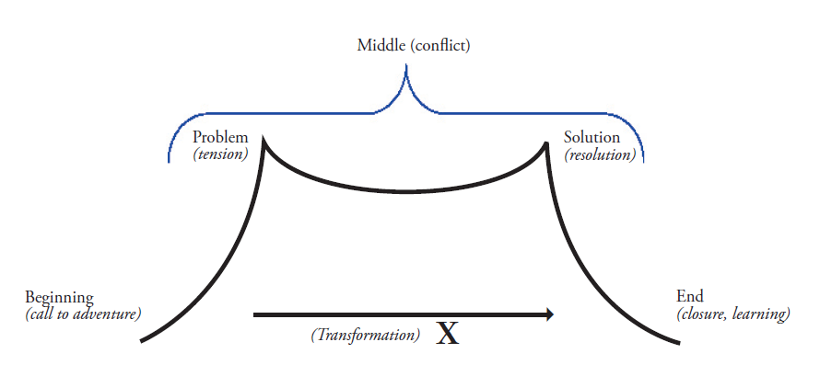

By thinking about digital stories in this way, you can relate it to your climate action project. The “call to adventure” can be presented when you share information about climate change, its impacts, and why it is problematic for your community. Then you may want to show the project design and implementation, which can be seen as the “tension, conflict” portion of the digital story arc. Lastly, the completion of the project would demonstrate the “resolution” and the reflection as a “closure” and “learning” process. Thinking about digital stories in this way allows you to visualize better and plan what they want to create.
In 8 Steps to Great Digital Storytelling, Samantha Morra provides a great overview of the digital storytelling process, as shown in the graphic below. Each of the steps is described in more detail in the article, which should be helpful to those just starting to explore digital storytelling and those teaching the process to others.

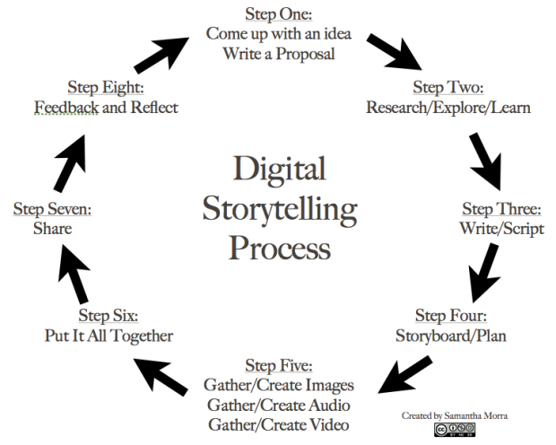

For the Climate Challenge, the digital story video should approximately 3 minutes. Keep in mind that longer is not necessarily better. The video should highlight the action project clearly communicating how it addresses a cause or impact of climate change. Students are encouraged to “show” rather than “tell” as much as possible—it is more exciting to see visual representations of the work rather than someone just talking into the camera.

VIDEO REQUIREMENTS:
- Save as .mp4, .mov, or .avi file
- Do not include copyrighted music. Free music is available at https://www.bensound.com.
Each student member is required to sign the Climate Challenge Digital Story Video Student Consent Form and Release. The completed forms from each student team member should be combined into a single file and uploaded into the Challenge Submission Form.

EASY WAYS TO MAKE A VIDEO:
- Use your cellphone and keep it casual (please use landscape/horizontal recording format)
- Create an online meeting and record the “meeting”
- Create a PowerPoint presentation with narration and export it as a video

FREE VIDEO EDITING SOFTWARE:
- Lightworks (advanced)
- VideoPad (great for beginners)
- Movie Maker Online (browser based)
- Cap cut pro
- Tiktok
- iMovie (Video: iMovie Tutorial for Beginners 11 minutes)
- Animoto is a way to create videos without the use of editing software
- WeVideo

Edutopia has put together a curated list of video tutorials to help people get started with filmmaking. There helpful tips on everything from no budget filmmaking gear to editing video, from storyboarding to planning camera angles.

Capturing live-action videos on phones or tablets is encouraged, but you can also draw pictures or diagrams or use animation tools to share your story. Online tools for video creation abound, with new platforms being introduced frequently. Here is an annotated list describing (mostly all free) resources to help create and use video. Some examples of student-created digital stories using these alternative online tools include:

- Speed drawings - https://youtu.be/U01jDsg2mLY
- Drawings - https://youtu.be/70u1w5kGbYg
- Animation using an online tool - https://youtu.be/5e4uKbXUGkM
- Stop motion with Legos - https://youtu.be/K0RvbAWU8PM

The Green Ninja project hosts an annual student film festival around student-made videos about their environmental action projects. You can find additional sample student-created videos on this YouTube playlist.

Young Voices for the Planet and Lens on Climate Change are two more organizations that offer educational resources around climate and environmental filmmaking. The Young Voices for the Planet films show how youth voices can use their influence to spearhead meaningful actions. Young Voices for the Planet also offers a civic engagement curriculum to assist students in designing, planning, and implementing a climate action project (free download with signup).

The Lens on Climate Change program guides students through creating documentary films to assist with understanding the science behind climate change. Sample student videos and curricular resources can be found on their website. They also offer a free e-book entitled Sharing Science with Film: A Guide to Student Productions, which includes tips for video production and a collection of video tutorials on technical aspects of filmmaking.

Submission Requirements and Form

To enter the Climate Challenge, each student team must complete a Submission Form by 11:59 pm on Friday, April 21, 2023. Please see the Official Challenge Rules document for additional details on the Challenge. To view a PDF copy of the Submission Form, click here. The student completing the submission form must sign into a Google account to complete the required file uploads. Google accounts are free, so one can quickly be created to complete the form.

The form requests the following information:

Section 1 – Contact Information

  - Teacher or Club Advisor First Name
  - Teacher or Club Advisor Last Name
  - Teacher or Club Advisor Email
  - School District Name
  - School Name
  - School Social Media (Facebook Account, Twitter Handle, Instagram Account Name, Tiktok Name)
  - Local News Outlets (TapInto, etc.)
  - Student Team Name
  - Number of Team Members
  - Grade Level of Student Team Members (Middle or High School)
  - Student Team Members' Name, Grade, and Student and Parent Email Addresses. Please provide this information using the Team Roster template.

Section 2 – Project Summary Information

  - Project Summary – Briefly describe the focus of your project and what inspired your team to take that approach.
  - Science Explanation – Explain how your project directly connects to and addresses a cause or impact of climate change. Teams are encouraged to do background research to make sure the science is clear and correct.
  - Project Highlights – Share three major highlights or takeaways from completing the project. For example:
- The challenges your team encountered and how you addressed them
- The lessons your team learned
- The relationships your team developed with experts and outside organizations

Section 3 – Video Details and File Upload

- Digital Story Title (10-word limit)
- Running time (min, sec)
- Signed Climate Challenge Digital Story Video Student Consent Form and Release forms (one form per student combined into a single file).
- Video File Upload – The video file can be uploaded into the submission form or a link to the video can be provided. THE LINK MUST ALLOW THE FILE TO BE DOWNLOADED BY ANYONE.
Note: The student completing the submission form will need to sign into a Google account to upload the video. Google accounts are free, so one can be easily made for the purposes of completing the video upload.

Submission Review Process

Each entry will be reviewed and evaluated by a panel of judges that includes educators and representatives from non-profits, state agencies, and the partner organizations. Entries will be placed in either a Middle School or High School category. Please see the Official Challenge Rules for additional Challenge details. All entries will be independently scored by the judges using the following scoring rubric.

All entries will be independently scored by the judges using the following scoring rubric.

Climate Challenge Scoring Rubric

Points | 4 | 3 | 2 | 1 | Total
Video Content |  |  |  |  | /12
Storytelling: Creative Elements | The video communicates to the audience in a creative way. It is interesting and engaging, and its purpose is clear. The digital narrative is clear and insightful and connects with the overall purpose of the project. | The story is creative and has several interesting and engaging elements with a set purpose. The digital narrative connects with the overall purpose of the project. | The story is generic and has few interesting or engaging elements related to the purpose of the video. The digital narrative loosely connects with the overall purpose of the project. | The story is difficult to follow or uninteresting. The project lacks a narrative and or overall connection to purpose. | /4
Core Science Ideas and Crosscutting Concept | The project clearly addresses a human impact on the environment; the cause-and-effect relationship (CCC-2) between human activity and climate change (ESS3.C) is accurately described and supported by evidence. | The project clearly addresses a human impact on the environment (ESS3.C); the cause-and-effect relationship (CCC-2) between human activity and climate change is described but not fully supported by evidence. | The project addresses a human impact on the environment but fails to describe the cause-and-effect relationship between human activity and climate change. | The tie to human impact is inadequate or missing entirely from the project. | /4
Solutions | The action project focuses on solutions that are innovative, practical, and may be implemented easily. | The action project includes solutions that are mostly practical and may be innovative. | The solutions suggested by the action project are impractical or difficult to implement. | There are no solutions given in the video, nor through the action project. | /4
Application |  |  |  |  | /8
Written Science Explanation | Climate science written descriptions—the cause-and-effect relationship between human activity and climate change—are accurate, well described, and clearly communicated. The science is closely related to the video. | Most climate science descriptions are accurate, well described, and clearly communicated. The science is related to the video. | Most climate science descriptions are vague or contain inaccuracies and explanations are confusing. The science may be only tangentially related to the video. | Climate science descriptions are missing or inaccurate. The science may be unrelated to the video. | /4
Written Project Components | The written project components section is descriptive and includes insightful, well described, and thoroughly detailed information about the design and completion of the action project. | The project components section is well described and has detailed information about the action project. | The project components section is included, but minimally addressed and/or without sufficient detail to fully describe the action project. | The project components section is incomplete or missing. Limited, or no additional information about the action project was provided. | /4
Total |  |  |  |  | /20

Challenge Awards

Finalist will be notified in May 2023. The student teams and their teachers will be recognized at an awards ceremony hosted by the Drumthwacket Foundation with New Jersey Governor and First Lady in June 2023. Schools with winning submissions will receive a grant to support their climate education initiatives (1st Place: $2,500, 2nd Place: $1,000, 3rd Place: $500). Students will receive an awards certificate and a commemorative gift.

Questions?

Email questions related to the Climate Challenge including the rules, submission requirements, deadlines, project eligibility requirements, or local organizations that could be a resource your project to:

njstudentclimatechallenge@sustainablejersey.com.

New Jersey Student Climate Challenge Program Partners

About Drumthwacket Foundation:
The Drumthwacket Foundation is a 501c3 non-profit, non-partisan organization. Its mission is to inspire pride and enhance civic awareness for all New Jerseyans by restoring Drumthwacket, a nationally landmarked historic site and the official residence of NJ Governors, and by educational and cultural activities that recognize the rich diversity and ongoing contributions of New Jersey’s communities and its residents.

About Atlantic City Electric:
Atlantic City Electric is a unit of Exelon Corporation (Nasdaq: EXC), the nation’s leading energy provider, with approximately 10 million customers. Atlantic City Electric provides safe and reliable energy service to approximately 560,000 customers in southern New Jersey.

About the Exelon Foundation:
The Exelon Foundation is an independent, nonprofit organization funded solely by Exelon Corporation through shareholder dollars. The mission of the Foundation is to encourage respect for the environment, support innovative STEM education programs and strengthen the social and economic fabric of the community by providing a match to Exelon employee contributions.

About Sustainable Jersey for Schools
Sustainable Jersey for Schools is a certification program for public schools in New Jersey. It provides tools, training, and financial incentives to support and reward schools as they pursue sustainability programs. To date, 388 district schools and 1,058 schools are participating in the program. Sustainable Jersey for Schools has awarded over $2.8 million in grants to schools and school districts. Follow Sustainable Jersey for Schools on Twitter @SJ_schools.

